Market update

1 CoreLogic May results

- Annual growth figures:
  - All capitals bar Melbourne and Perth above 10%
  - As the poorer months of June, July, August drop off – this number will balloon up and that’s when we’ll see it on the news
- Perth – April and May – Perth had the lowest growth, March it had second lowest growth of all the capital cities.
  - We predicted at the beginning of the year that Perth would take off, but that hasn’t been the case so far.
  - Perhaps this is because of closed boarders
- Capitals beat regionals for the month and quarter
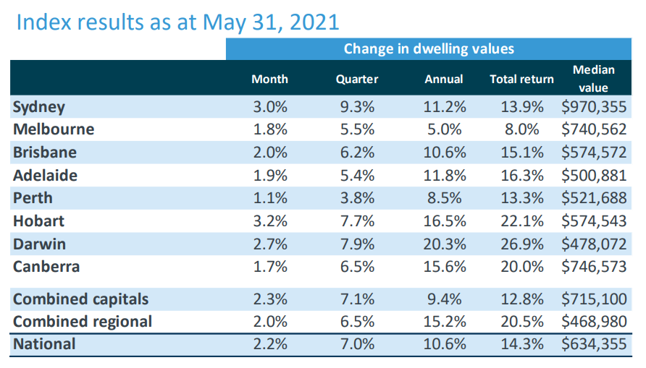

Pete’s points
Suburb | Median House Price March 2020 | No. of sales | Median House Price March 2021 | No. of sales | Price Change
Port Noarlunga | $370,000 | 13 | $400,000 | 9 | 8.1%
Port Noarlunga South | $411,000 | 15 | $447,000 | 9 | 8.8%
Christies Beach | $345,000 | 27 | $395,000 | 38 | 14.5%
Aldinga Beach | $363,000 | 54 | $420,000 | 54 | 15.7%
Seaford | $350,000 | 12 | $423,000 | 21 | 20.9%
Moana | $435,000 | 13 | $530,000 | 12 | 21.8%
Port Willunga | $383,000 | 7 | $480,000 | 6 | 25.3%
Maslin Beach | SNR | 4 | $486,000 | 10 | SNR

Note: Beware the small number of sales in Port Willunga, which coincidentally resulted in the greatest increase in price.

Port Noarlunga matched the performance of the Adelaide metropolitan area and all the other suburbs outperformed. The best suburbs were Seaford, Moana and Port Willunga where house prices increased by more than 20% in the 12 month period.
Some of the increase in house prices can be attributed to the rise in demand for premium property, especially along the Esplanade. I have selected four of the suburbs to illustrate the marked change in premium property in the last 12 months.

Port Noarlunga South
Property Address and Details - to May 2020 | Sale Price | Property Address and Details – to May 2021 | Sale Price | Increase
17 Berwick St.  4 bedrooms, land – 407 sqm | $810,000 | 4 Truro St.  Bedrooms, land – 413 sqm | $900,000
17A Berwick St  4 bedrooms, land – 406 sqm | $815,000 | 165 Esplanade  Vacant land – 827 sqm | $1.02m
8 Truro St.  4 bedrooms, land – 733 sqm | $850,000 | 126A Esplanade  3 bedrooms, land – 404 sqm | $1.15m
Average Price | $825,000 |  | $1.02m | 24%

Christies Beach
Property Address and Details - to May 2020 | Sale Price | Property Address and Details – to May 2021 | Sale Price | Increase
72 Esplanade  3 bedrooms, land – 357 sqm | $697,000 | 69 Esplanade  4 bedrooms, land – 666 sqm | $910,000
7 Gilbert Rd.  5 bedrooms, land – 705 sqm | $720,000 | 54 Esplanade  3 bedrooms, land – 834 sqm | $1.16m
4 Esplanade  3 bedrooms, land – 900 sqm | $800,000 | 19-20 Esplanade  2 houses, land – 1944 sqm | $1.87m
Average Price | $739,000 |  | $1.31m | 77%

Note: Beware the sale price of 19-20 esplanade which was a huge block of land as it was actually two properties included in the one sale.

Aldinga Beach
Property Address and Details - to May 2020 | Sale Price | Property Address and Details – to May 2021 | Sale Price
317 Esplanade  5 bedrooms, land – 690 sqm | $900,000 | 111 Esplanade  5 bedrooms, land – 740 sqm | $1.3m
81 Esplanade  3 bedrooms, land – 700 sqm | $970,000 | 192 Esplanade  4 bedrooms, land – 348 sqm | $1.4m
287 Esplanade  5 bedrooms, land – 706 sqm | $1.15m | 1 Sheoak Ave.  4 bedrooms, land - 848 sqm | $1.68m
Average Price | $1.01m |  | $1.46m | 45%

Seaford
Property Address and Details - to May 2020 | Sale Price | Property Address and Details – to May 2021 | Sale Price
295 Esplanade  3 bedrooms, land – 596 sqm | $610,000 | 248 Esplanade  5 bedrooms, land – 679 sqm | $938,000
252 Esplanade  5 bedrooms, land – 543 sqm | $860,000 | 243 Esplanade  3 bedrooms, land – 344 sqm | $1.1m
250 Esplanade  4 bedrooms, land – 353 sqm | $924,000 | 221 Esplanade  5 bedrooms, land – 852 sqm | $1.2m
Average Price | $798,000 |  | $1.08m | 35%

